REST - GET COUNTRY BASED ON COUNTRY CODE

Write a REST service that returns a specific country based on countrycode. The country code should be case insensitive.
Controller: com.cognizant.spring-learn.controller.CountryController
Method Annotation: @GetMapping("/countries/{code}")
Method Name: getCountry(String code)
Method Implemetation: Invoke countryService.getCountry(code)
Service Method: com.cognizant.springlearn.service.CountryService.getCountry(String code)

Service Method Implementation:
- Get the country code using @PathVariable
- Get country list from country.xml
- Iterate through the country list
- Make a case insensitive matching of country code and return the country.
- Lambda expression can also be used instead of iterating the country list
SpringLearnApplication.java
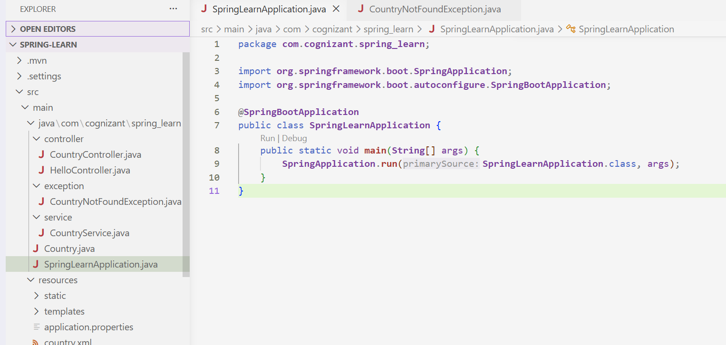

CountryController.java:
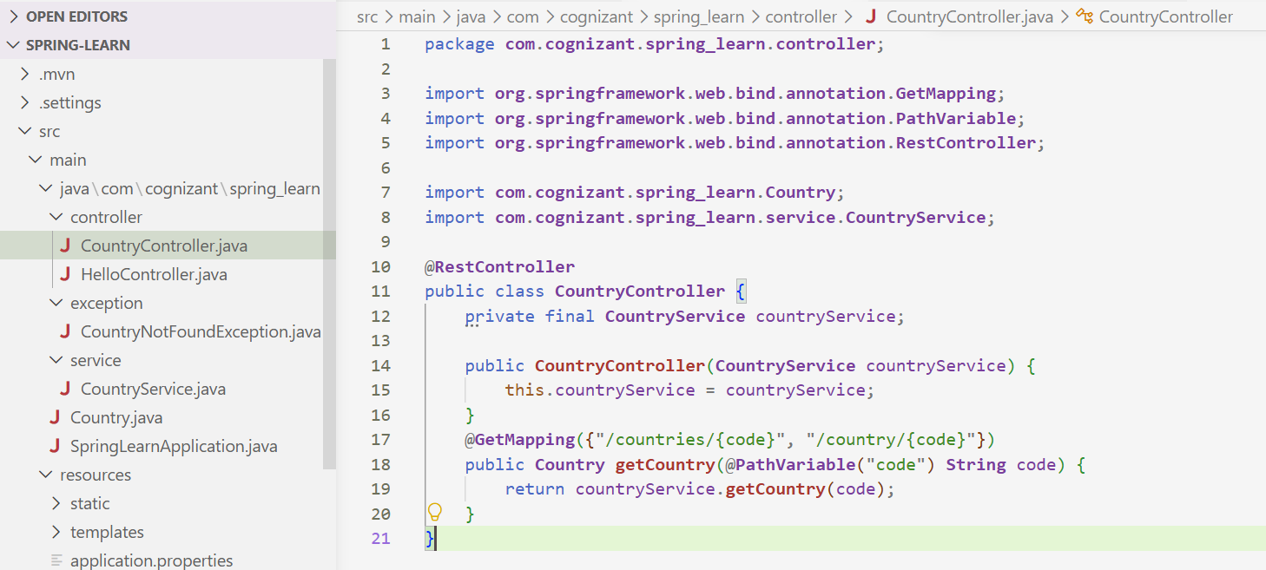
CountryService.java:
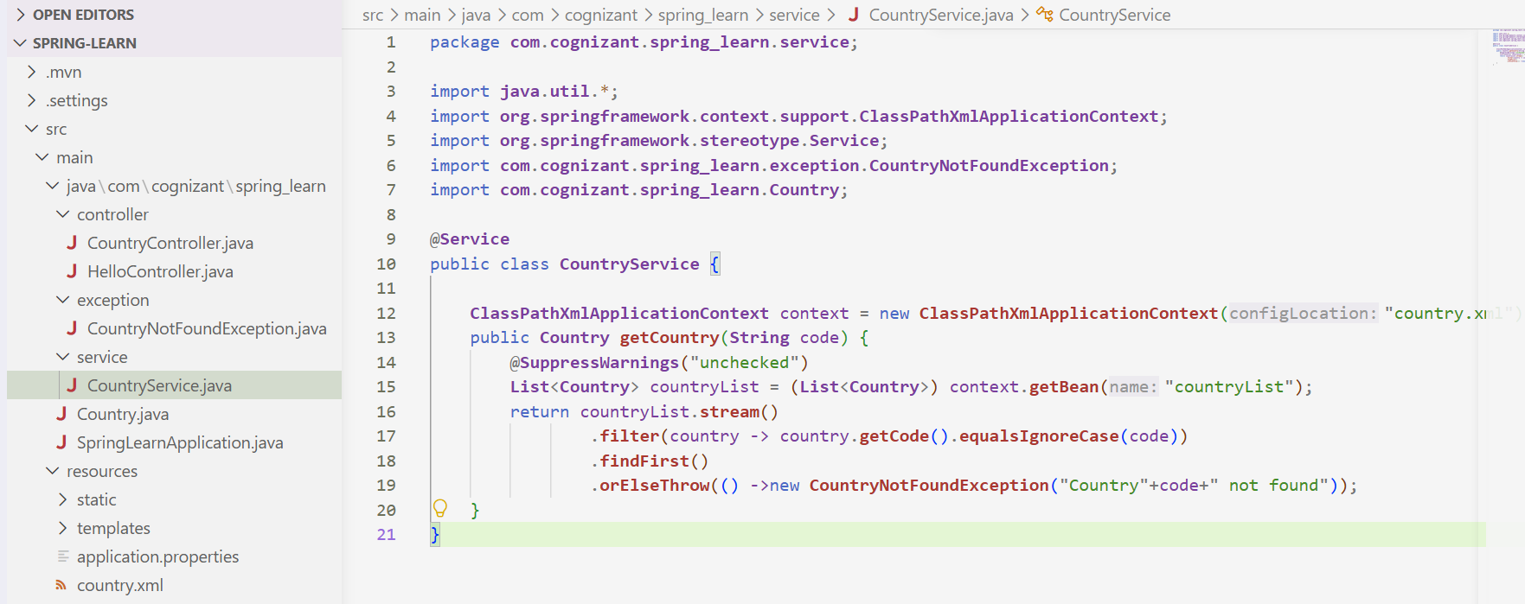
CountryNotFoundException.java:
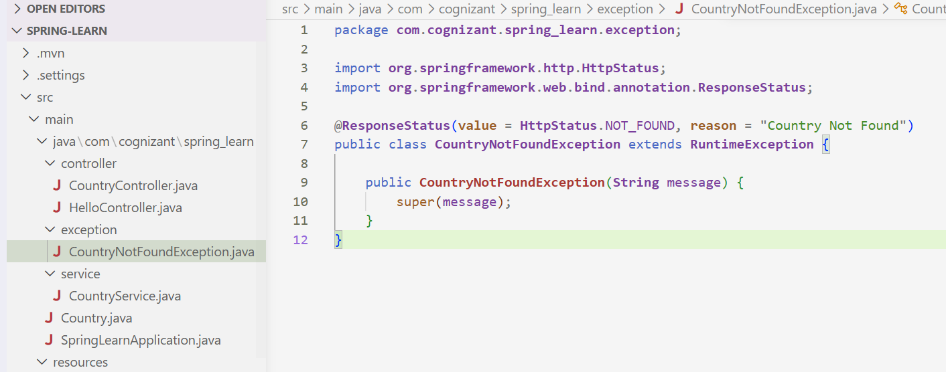
Country.xml:
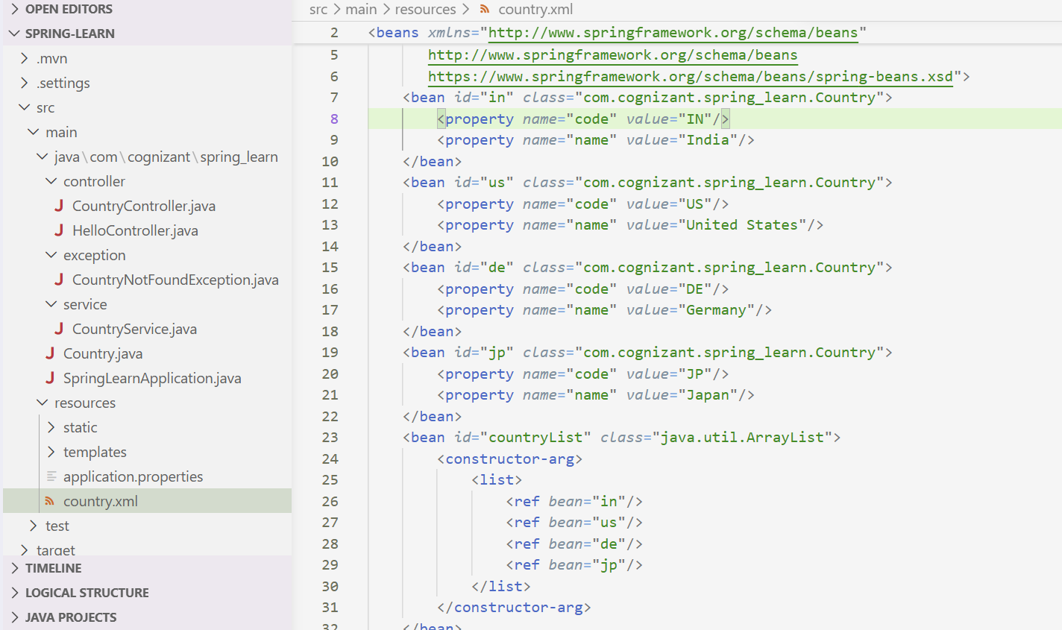

Country.java
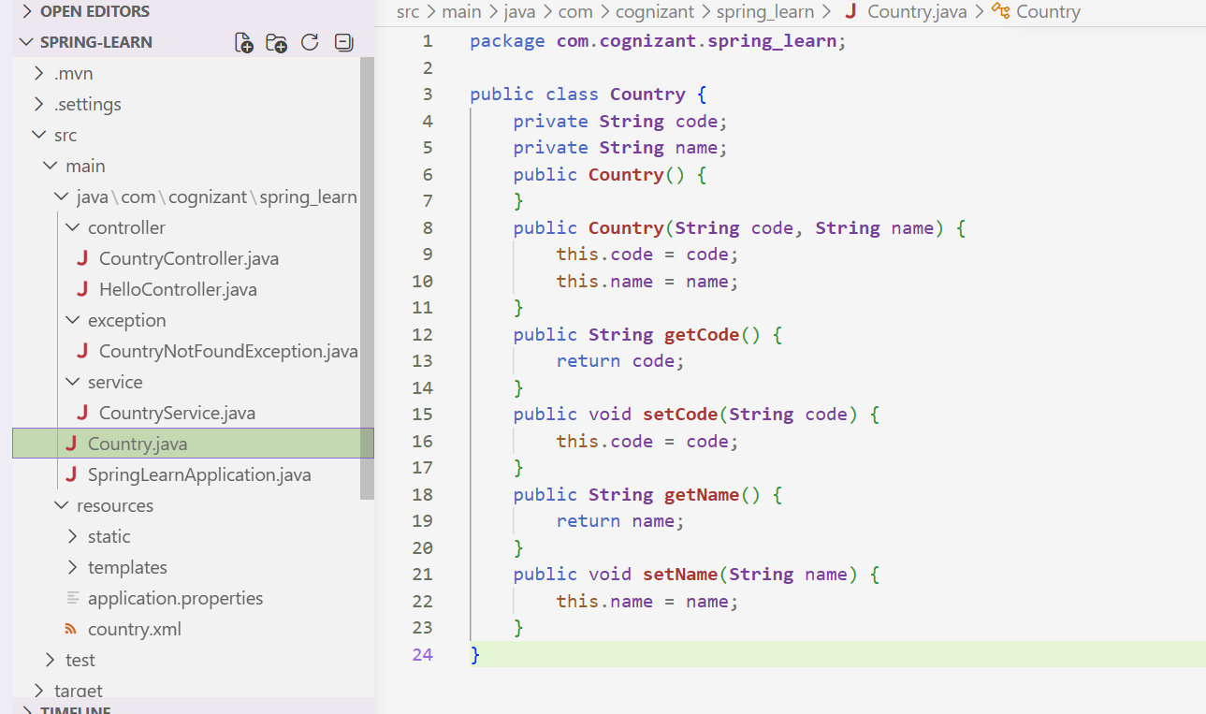

Output:
Request: http://localhost:8080/country/IN
Response:
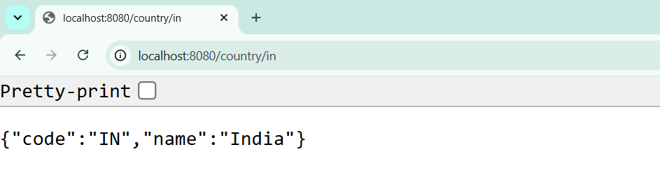
Request: http://localhost:8080/country/De
Response:
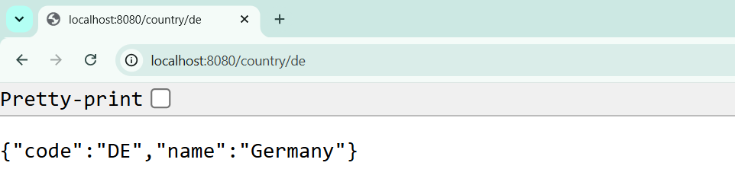
Request: http://localhost:8080/country/us
Response:
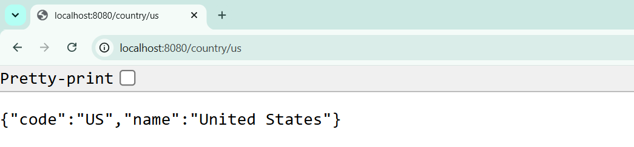
Request: http://localhost:8080/country/jp
Response:
